Assignment 1 – Benchmark App

SD6503 - Testing & Secure Coding

Chunguang liu 2230873

2024

# Unit Testing - Staff

|  |  |  |  |  |  |
| --- | --- | --- | --- | --- | --- |
| Test Number | Test Case | Class | Input | Output | Pass/Fail |
| TC_UT_01 | Verify the Id property | Staff | int:  “1” | Id should be “1” | Y |
| TC_UT_02 | Verify the Name property | Staff | String:  “Siri” | Name should be “Siri” | Y |
| TC_UT_03 | Verify the Department property | Staff | String:  “Sales” | Department should be “Sales” | Y |
| TC_UT_04 | Verify the AnnualSalary property | Staff | int:  “50000” | AnnualSalary should be “50000” | Y |
| TC_UT_05 | Verify the default constructor | Staff | NA | Id should be 0  Name should be "NA"  Department should be "NA"  AnnualSalary should be 0 | Y |
| TC_UT_06 | Verify ToString Method Format | Staff | Id: 1  Name: "Siri"  Department: "Finance"  AnnualSalary: 55000 | The ToString method should return the string:  "ID: 1 Name: Siri Dept: Finance Ann.sal: 55000" | Y |

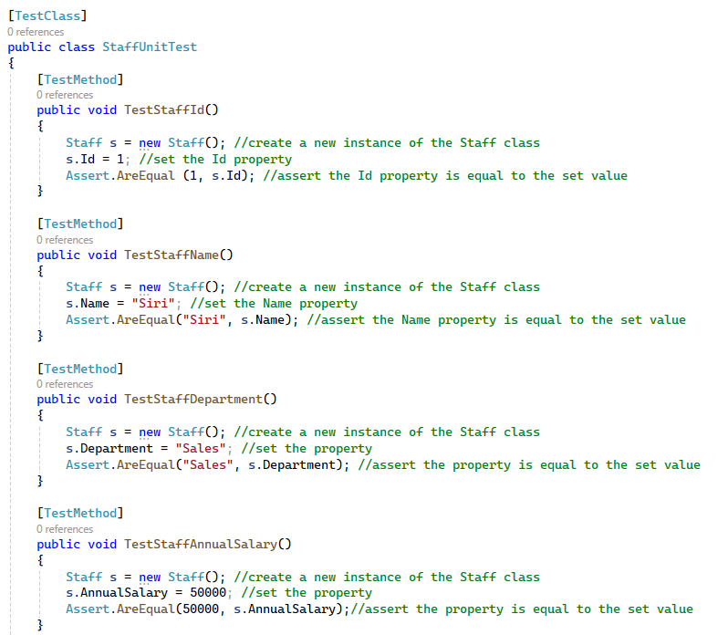

Figure 1: TC_UT_01 - TC_UT_04

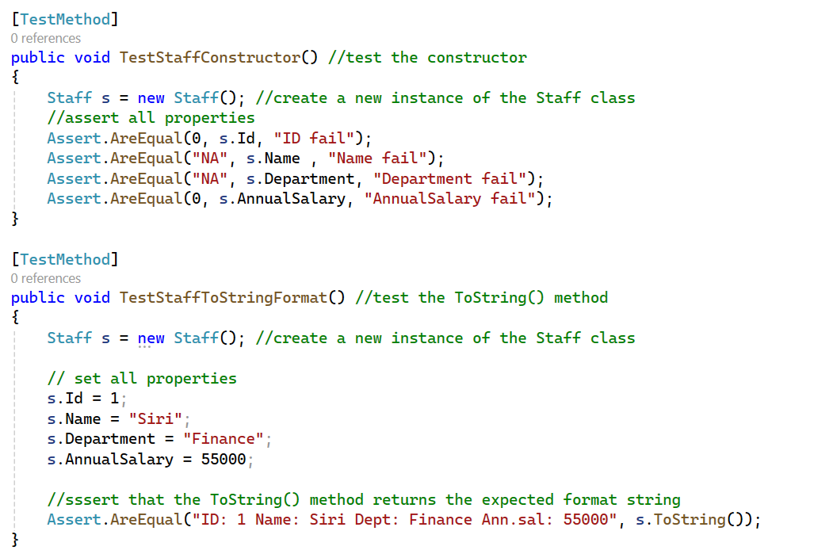

Figure 2: TC_UT_05 - TC_UT_06

# Unit Testing - Filter

|  |  |  |  |  |  |
| --- | --- | --- | --- | --- | --- |
| Test Number | Test Case | Class | Input | Output | Pass/Fail |
| TC_UT_07 | Verify the SortAZ method returns a List<Staff> correctly sorted in ascending order | Filter | Four Staff objects with initialized fields | A List< Staff > arranged in ascending order by Name | Y |
| TC_UT_08 | Verify the SortZA method returns a List<Staff> correctly sorted in descending order | Filter | Four Staff objects with initialized fields | A List< Staff > arranged in descending order by Name | Y |
| TC_UT_09 | Verify the Search method | Filter | Four names: Fluffy, Butch, Buggs, Frankie | Can search by a letter “u” in Name. Fluffy, Butch, Buggs should be contained. | Y |

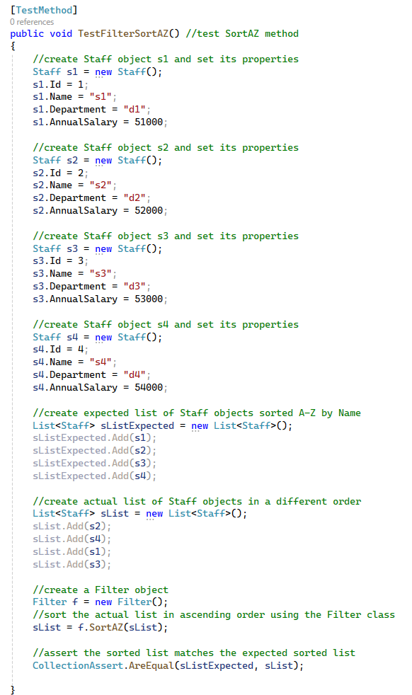 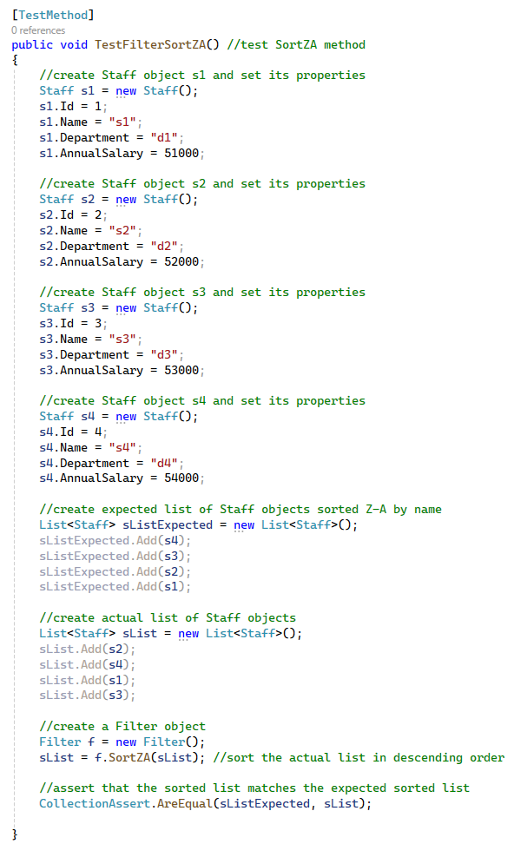

Figure 3: TC_UT_7 Figure 4: TC_UT_8

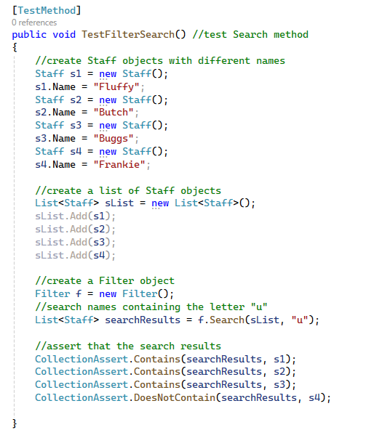

Figure 5: TC_UC_9

# Unit Testing - FileManager

|  |  |  |  |  |  |
| --- | --- | --- | --- | --- | --- |
| Test Number | Test Case | Class | Input | Output | Pass/Fail |
| TC_UT_10 | Verify the LoadStaff can return a list of staff objects | FileManager | 5 test data | A List containing 5 Staff objects | Y |
| TC_UT_11 | Verify the SaveStaff method save a single staff to a text file | FileManager | Id=10, Name="Harry", Department="Sales", AnnualSalary=54000 | A text file containing:  “10, Harry, Sales, 54000” | Y |
| TC_UT_12 | Verify the SaveAllStaff method save multiple staff objects to a text file | FileManager | Staff Id=1, Name="Alice", Department="HR", AnnualSalary=50000  Staff Id=2, Name="Bob", Department="IT", AnnualSalary=60000 | A text file containing:  “1,Alice,HR,50000  2,Bob,IT,60000” | Y |

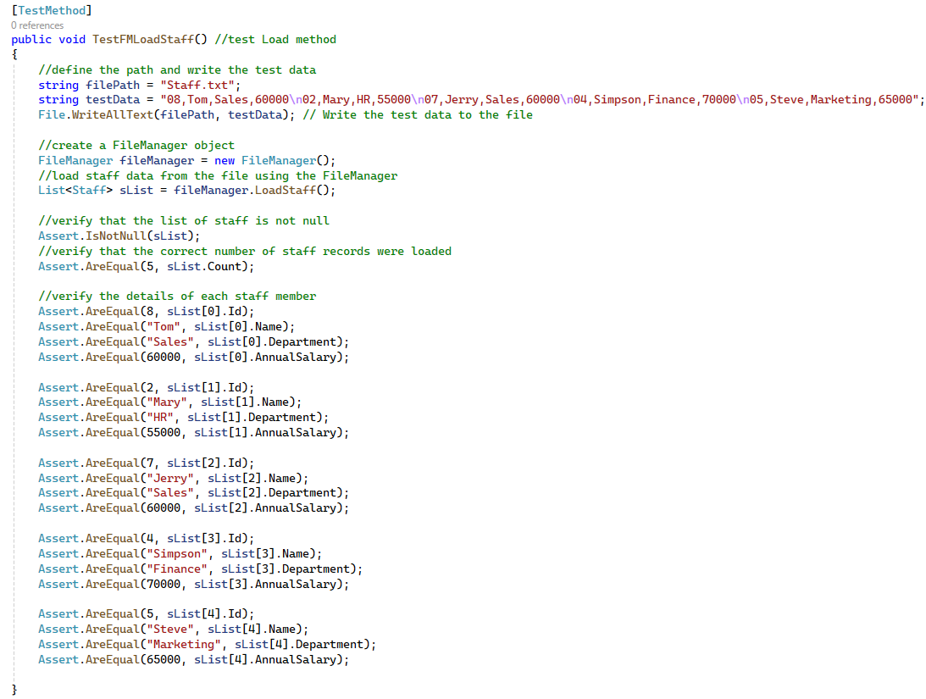

Figure 6: TC_UT_10

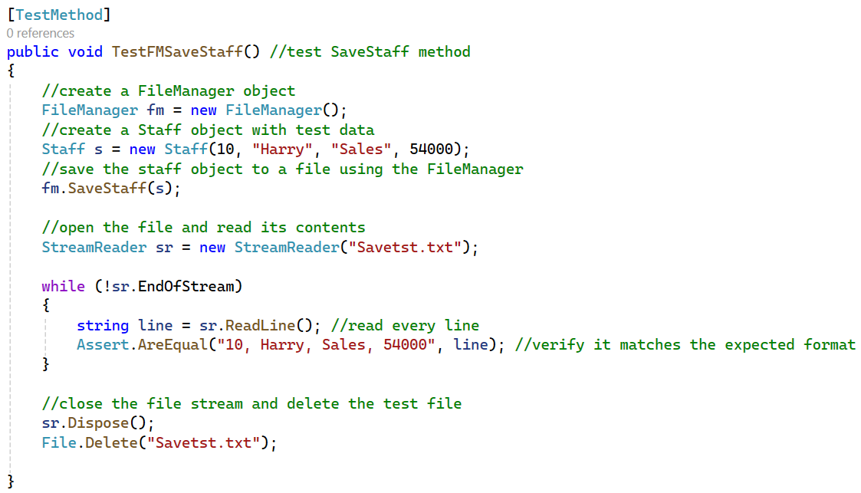

Figure 7: TC_UT_11

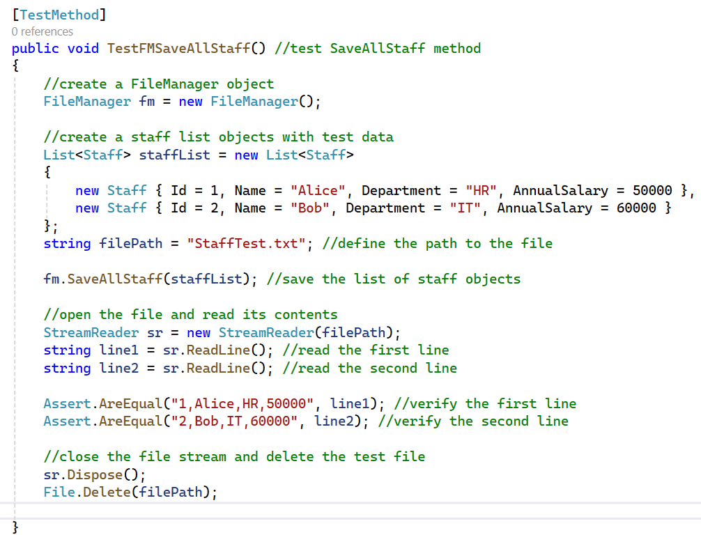

*Figure 8: TC_UT_12*

# Unit Test Results

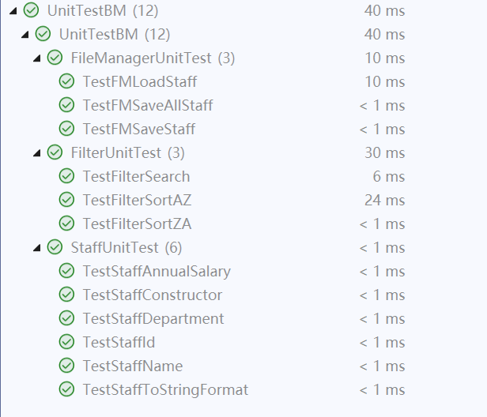

Figure 9: Results for all unit tests